Michael Dang – 16257750

STAT5572

Homework 4

11/27/2023

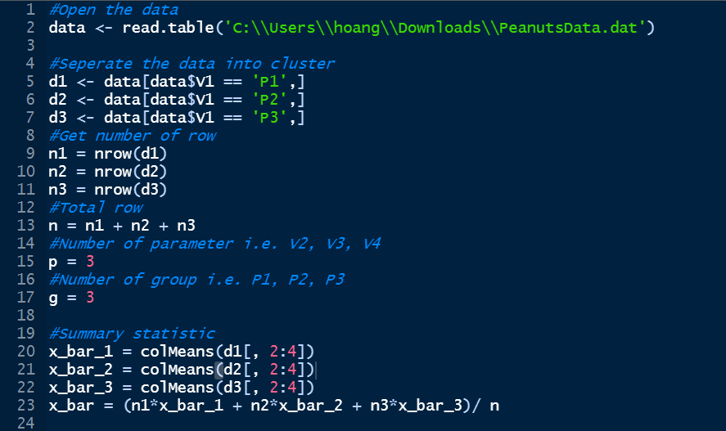

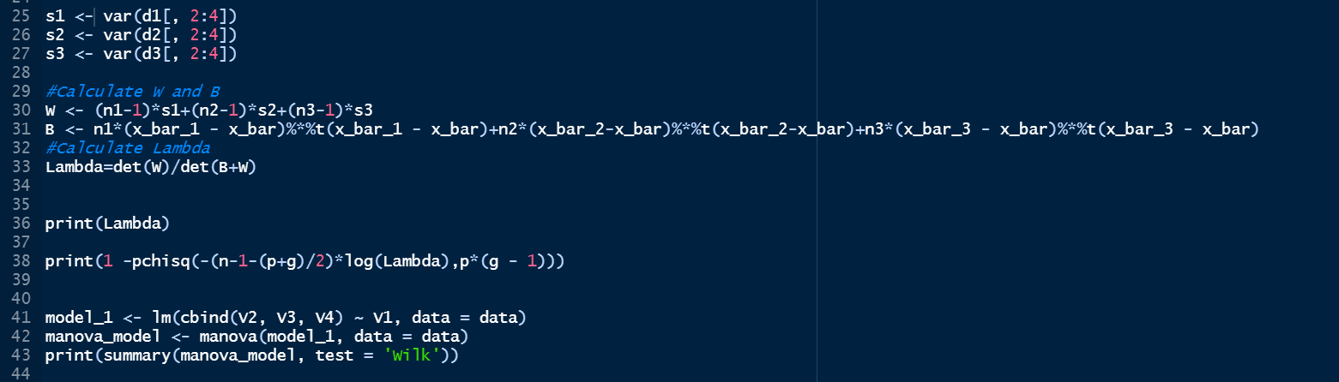

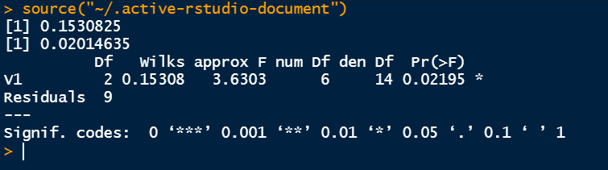

Since p-value (0.02) < alpha (0.05), we have evidence to reject the null hypothesis.

Hence, we may conclude that there are significant differences in at least one of the Yields, Sound mature Kernels, and Seed sizes among the peanut varieties.